Quantium Retail Analytics – Report
Objective
The objective of this analysis was to understand customer purchasing behaviour within the chips category and identify the customer segments that contribute the highest sales. The findings will help support strategic recommendations for the Category Manager.

1. Data Preparation
Datasets Used
- QVI_transaction_data.xlsx
- QVI_purchase_behaviour.csv
The datasets were imported into RStudio and checked for:
- Missing values
- Duplicate records
- Incorrect data formats
- Outliers
- Product inconsistencies

2. Data Cleaning Process
2.1 Missing Values
The datasets were checked using:
colSums(is.na(transaction_data))
colSums(is.na(purchase_behaviour))
No major missing value issues were identified.

2.2 Duplicate Records
Duplicate rows were checked using:
sum(duplicated(transaction_data))
sum(duplicated(purchase_behaviour))
Duplicates were removed where necessary using the distinct() function.

2.3 Date Conversion
The DATE column was initially stored in numeric format and converted into proper date format.
transaction_data$DATE <- as.Date(transaction_data$DATE,
origin = "1899-12-30")

2.4 Removing Non-Chip Products
The analysis focused only on chips products. Salsa products were removed from the dataset.
transaction_data <- transaction_data %>%
filter(!str_detect(PROD_NAME, "Salsa"))

2.5 Outlier Detection
Outliers were identified using boxplots and transaction quantity analysis.
A customer purchasing 200 packets in one transaction was identified as an outlier and removed because it likely represented commercial purchasing rather than regular customer behaviour.
transaction_data <- transaction_data %>%
filter(PROD_QTY < 200)

3. Feature Engineering
3.1 Pack Size Extraction
Pack size was extracted from the product name.
transaction_data$PACK_SIZE <- str_extract(transaction_data$PROD_NAME,
"\\d+")

3.2 Brand Extraction
Brand names were derived from product names.
transaction_data$BRAND <- word(transaction_data$PROD_NAME, 1)
Brand inconsistencies were standardised where required.

4. Merging Datasets
Both datasets were merged using the loyalty card number.
merged_data <- merge(transaction_data,
purchase_behaviour,
by = "LYLTY_CARD_NBR")
This created a consolidated dataset containing:
- Transaction details
- Product details
- Customer segment information

5. Exploratory Data Analysis
5.1 Total Sales
Total sales were calculated using:
sum(merged_data$TOT_SALES)
The chips category generated strong overall revenue across all customer groups.

5.2 Customer Segmentation Analysis
Sales were analyzed across:
- Lifestage
- Premium customer category
Key metrics included:
- Total sales
- Quantity purchased
- Number of customers
- Average price per unit

6. Key Findings
6.1 Highest Contributing Segment
The highest sales contribution came from:
OLDER FAMILIES – Budget
This segment generated the highest total sales overall.
Key characteristics:
- High purchase frequency
- Large quantity purchases
- Strong contribution to total revenue

6.2 Mainstream Young Singles/Couples
This segment was one of the strongest contributors to chip sales.
Observations:
- Purchased chips frequently
- Higher average price per unit
- Strong preference for mainstream brands
This indicates that younger mainstream shoppers are highly engaged in the chips category.

6.3 Retirees Segment
Retirees also contributed significantly to sales, especially mainstream retirees.
Characteristics:
- Consistent purchasing behaviour
- Stable spending patterns
- Strong transaction volume

6.4 Pack Size Trends
The most commonly purchased pack sizes were medium-sized packets around:
- 170g
- 175g
These sizes generated the highest sales contribution.
Smaller pack sizes showed lower total sales compared to family-sized packs.

6.5 Brand Preferences
The leading chip brands included:
- Kettle
- Smiths
- Doritos
- Pringles
These brands consistently generated strong sales across customer segments.
Kettle products showed particularly strong performance among mainstream customers.

7. Commercial Insights
The analysis suggests that chip purchasing behaviour is heavily influenced by:
- Household size
- Customer lifestyle
- Price sensitivity
- Brand preference
Budget family segments tend to purchase larger quantities, while mainstream younger customers are willing to spend more per unit.
This creates opportunities for both:
- Volume-driven promotions
- Premium product positioning

8. Recommendations
Recommendation 1: Target Older Families
Older Families (Budget segment) contribute the highest sales volume.
Suggested strategies:
- Family-size promotions
- Multi-buy discounts
- Bundle offers

Recommendation 2: Focus on Mainstream Young Singles/Couples
This segment demonstrates high engagement with chips products.
Suggested strategies:
- Trend-focused marketing campaigns
- Premium flavour launches
- Digital promotions and loyalty offers

Recommendation 3: Increase Visibility of Top Brands
Brands such as Kettle and Smiths should receive stronger in-store visibility.
Suggested actions:
- End-of-aisle displays
- Promotional placements
- Featured product campaigns

Recommendation 4: Prioritize Popular Pack Sizes
Since 170g–175g packets dominate sales:
- Inventory should prioritize these sizes
- Promotions should focus on these high-performing products

9. Graphs
1. OUTLIERS
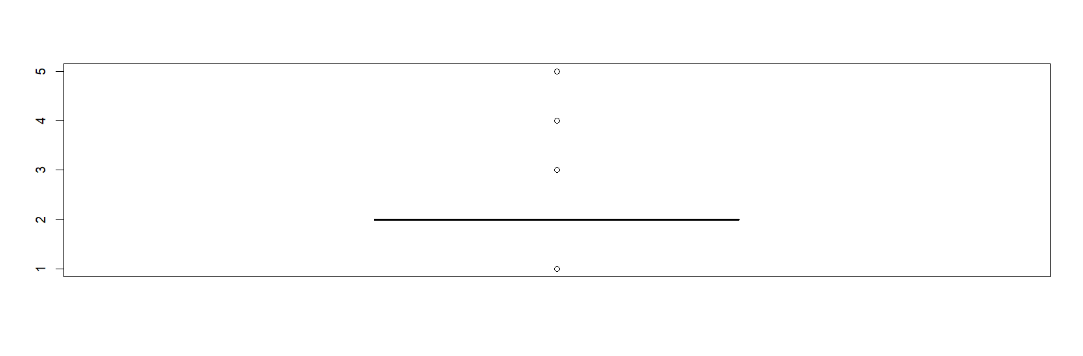
2.Final Visuals: Total sales v/s Lifestage
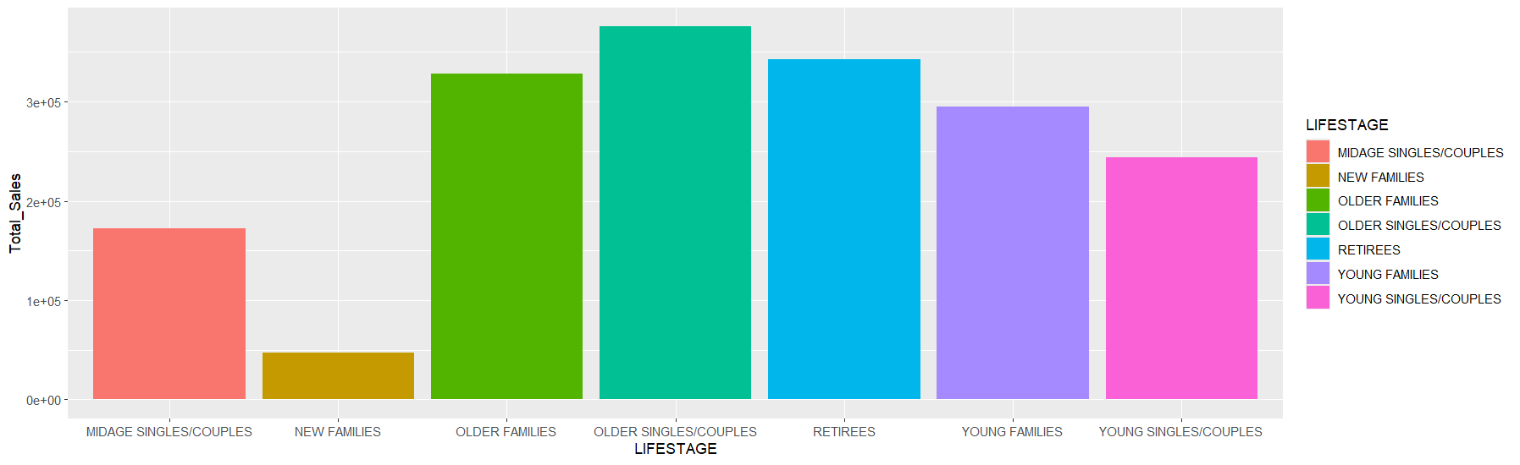

10. Conclusion
The analysis identified clear differences in purchasing behaviour across customer segments.
Key conclusions:
- Older Families (Budget) are the highest overall contributors to sales.
- Mainstream Young Singles/Couples are highly engaged and pay higher prices per unit.
- Medium-sized chip packets dominate customer preference.
- Kettle and Smiths are the strongest-performing brands.
These findings provide valuable commercial insights that can support future category planning, targeted marketing, and promotional strategies for the chips category.

